**Calculating Family Expenses using Service Now**

**TABLE OF CONTENTS**

|  |  |  |
| --- | --- | --- |
| **CHAPTER NO.** | **TITLE** | **PAGE NO.** |
| **-** | **ABSTRACT** | **4** |
| **1** | **Introdution** | **5** |
|  | 1.1 Current Issues | **5** |
| 1.2 Service Now | **5** |
| 1.3 Uses of Service now in Family Expenses | **6** |
| **2** | **Develeoping the Family Expense Calculation System in Servicenow Developer Instance** | **8** |
|  | 3.1 Hardware Requirements | **8** |
| 3.2 Software Requirements | **10** |
| **3** | **DESIGN AND IMPLEMENTATION** | **14** |
|  | 4.1 Architecture Diagram | **14** |
| 4.2 Dataflow Diagram | **15** |
| 4.3 Use Case Diagram | **16** |
| 4.4 Sequence Diagram | **19** |
| 4.5 Collaborative Diagram | **20** |
| 4.6 Database Design | **21** |
| **4** | **TESTING** | **24** |
|  | 5.1 Introduction | **24** |
| 5.2 Types of Testing | **24** |
| 5.3 Test Cases | **25** |
| 5.4 Test Data | **26** |
| 5.5 Test Report | **26** |
| 5.6 Code Test Cases and Outputs | **27** |
| 5.7 API Testing | **29** |
| **6** | **SYSTEM IMPLEMENTATION** | **32** |
|  | **6.1** Module Description | **32** |
| **6.2** Algorithms | **34** |
| **6.3** Database Module | **38** |
| **7** | **CONCLUSION AND FUTURE ENHANCEMENT** | **39** |
|  | **7.1** Conclusion | **39** |
| **7.2** Future Enhancement | **39** |
| **8** | **APPENDICES** | **41** |
|  | 8.1 Coding | **41** |
| 8.2 Screen Shots | **64** |
| **9** | **BIBLIOGRAPHY** | **72** |

**Abstract**

The project *“Calculating Family Expenses using ServiceNow”* is aimed at designing and implementing a comprehensive expense management system by leveraging the capabilities of the ServiceNow platform. In today’s fast-paced lifestyle, families often face challenges in systematically tracking and controlling their expenditures, which can lead to financial mismanagement and stress. To address this issue, the proposed system provides a centralized platform where users can record, categorize, and analyze family expenses in a structured manner.

The system incorporates essential features such as expense categorization into predefined groups (e.g., food, utilities, education, healthcare, and entertainment), budget setting for each category, and real-time expense tracking to prevent overspending. It also includes automated reporting and visualization tools that help families gain deeper insights into their spending patterns. By using ServiceNow’s workflow automation, database management, and integration capabilities, the project ensures a seamless user experience, data accuracy, and scalability to support families of different sizes and financial structures.

The solution emphasizes user-friendly design, ensuring that even non-technical users can manage their financial data effortlessly. Furthermore, the system’s adaptability allows it to be extended with advanced features such as alerts for budget limits, monthly summaries, and potential integration with external financial tools. Ultimately, the project provides a robust framework to promote financial awareness, informed decision-making, and long-term financial stability for families.

**Chapter : 1 : Introduction**

Managing family expenses has become an essential aspect of modern life, as financial stability plays a critical role in ensuring the overall well-being of households. With the increasing number of daily expenditures and diverse financial commitments, families often find it challenging to monitor their spending effectively. Traditional methods, such as manual tracking or using spreadsheets, are time-consuming, error-prone, and lack real-time insights. This creates the need for a smarter, automated, and user-friendly solution that simplifies financial management.

The project *“Calculating Family Expenses using ServiceNow”* addresses this challenge by utilizing the powerful capabilities of the ServiceNow platform to develop an expense management system tailored for families. ServiceNow, known for its robust workflow automation, data handling, and integration features, provides a strong foundation for building scalable and efficient applications beyond its conventional IT service management use.

This system allows users to record and categorize expenses under various heads, set budgets for each category, and track them in real time. The platform further provides detailed reports and analytics, helping families identify spending patterns, control unnecessary expenditures, and make informed financial decisions. With a focus on user experience, the system is designed to be intuitive and accessible, ensuring that even users with minimal technical knowledge can operate it with ease.

By integrating advanced functionalities such as automated alerts for budget limits, monthly expenditure summaries, and data visualization, the project not only streamlines the expense management process but also encourages families to develop better financial discipline. Ultimately, this project contributes towards promoting financial awareness, transparency, and long-term financial well-being within the family unit.

* 1. **Current Issues:**

Managing family expenses manually or through basic digital tools comes with several challenges that often result in financial mismanagement. Some of the key issues identified are:

1. **Lack of Centralized Tracking**
   * Families usually depend on notebooks, spreadsheets, or different mobile apps for expense tracking, which leads to scattered and unorganized financial data.
2. **Difficulty in Categorization**
   * Expenses are not always properly classified under categories like food, utilities, healthcare, or education. This makes it hard to understand where the majority of money is being spent.
3. **Time-Consuming Process**
   * Manual entry and calculation of expenses require significant time and effort, often discouraging consistent tracking.
4. **Inaccurate Budget Monitoring**
   * Without automated tools, families may overshoot their budget unknowingly, since there is no real-time alert mechanism.
5. **Limited Analytical Insights**
   * Basic methods of tracking do not provide detailed insights, such as monthly trends, spending patterns, or comparative analysis across categories.
6. **Data Security and Reliability**
   * Using third-party tools or manual records may compromise financial data security and lack reliability for long-term record keeping.
7. **Scalability Issues**
   * As family size and expenses grow, traditional methods fail to scale, making it increasingly difficult to manage finances effectively.
   1. **Service Now:**

ServiceNow is a **cloud-based platform** that provides digital workflows to automate and streamline business processes across different industries. Originally developed for IT Service Management (ITSM), ServiceNow has now expanded into areas such as Human Resources, Customer Service, Security Operations, and custom application development.

The key strength of ServiceNow lies in its ability to:

* **Automate workflows** – Reduces manual work by handling routine and repetitive tasks automatically.
* **Centralize data** – Stores and manages information in a single system of record, improving accessibility and accuracy.
* **Support custom applications** – Allows developers and users to create applications tailored to specific needs without complex coding.
* **Provide reporting and dashboards** – Offers real-time insights into processes, trends, and performance metrics.
* **Ensure scalability and security** – Handles large-scale operations with strong data protection measures.

ServiceNow is widely used by organizations because it increases efficiency, enhances user experience, and reduces operational costs. In this project, ServiceNow is utilized beyond its traditional business uses, serving as a platform to build a **family expense management system** that helps users track, categorize, and analyze their financial activities in a simple and effective way.

* 1. **Uses of Service Now in Family Expenses:**

The selection of ServiceNow as the platform for developing the *“Calculating Family Expenses”* system brings several advantages, as it provides powerful tools for automation, integration, and scalability. The following are the key uses of ServiceNow in this project:

1. **Centralized Platform**
   * ServiceNow offers a single, unified platform where all family expense data can be stored, tracked, and managed efficiently.
2. **Workflow Automation**
   * Routine tasks such as recording expenses, categorizing them, and generating reports can be automated, reducing manual effort and improving accuracy.
3. **Real-Time Tracking**
   * ServiceNow enables real-time expense monitoring, ensuring that users are always aware of their financial status and budget utilization.
4. **Customization and Scalability**
   * The platform supports customization to adapt to different family sizes, expense categories, and financial complexities. It can easily scale as the family’s financial requirements grow.
5. **Reporting and Analytics**
   * ServiceNow provides built-in reporting and dashboard features that can generate monthly summaries, visualizations, and detailed insights into spending patterns.
6. **Integration Capabilities**
   * The system can be integrated with other financial tools, applications, or external data sources, further enhancing functionality.
7. **User-Friendly Interface**
   * ServiceNow’s intuitive design and form-based structure make it easy for non-technical users to enter and analyze expense data without difficulty.
8. **Data Security and Reliability**
   * ServiceNow ensures secure data storage with role-based access, protecting sensitive financial information from unauthorized use.

**Chapter : 2 :** Develeoping the Family Expense Calculation System in Servicenow Developer Instance

2.1. **Setting up ServiceNow Instance**

1. Sign up for a developer account on the ServiceNow Developer site “https://developer.servicenow.com”.
2. Once logged in, navigate to the "Personal Developer Instance" section.
3. Click on "Request Instance" to create a new ServiceNow instance.
4. Fill out the required information and submit the request.
5. You'll receive an email with the instance details once it's ready.
6. Log in to your ServiceNow instance using the provided credentials.
7. Now you will navigate to the ServiceNow.

2.2. **Creation of New Update Set**

1. Go to All >> In the filter search for Local Update set > click on New.

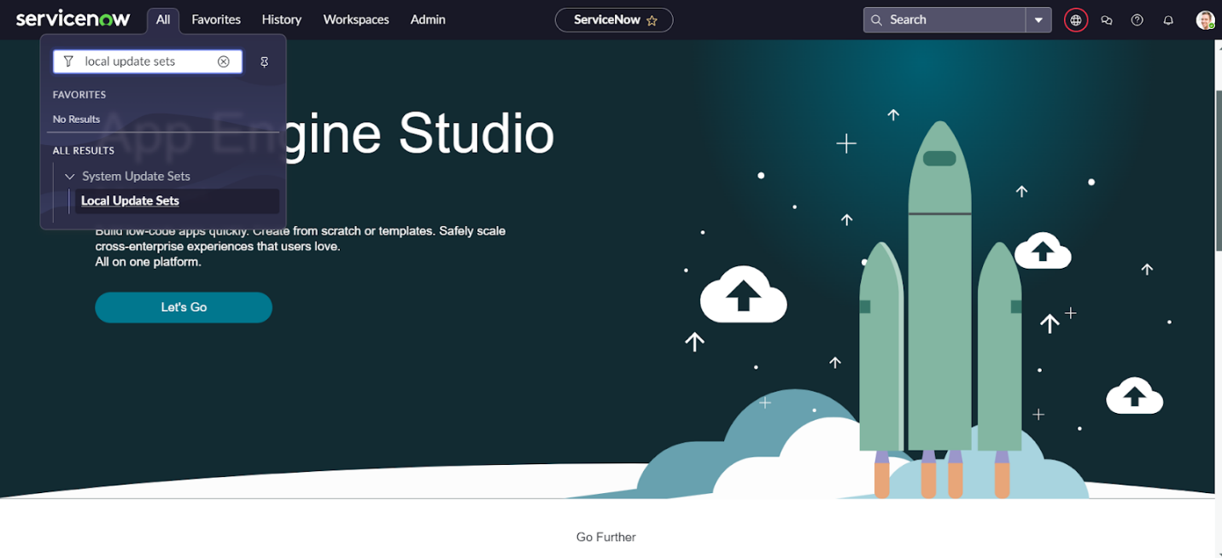

1. Enter the Details as:

Name : Family Expenses

1. 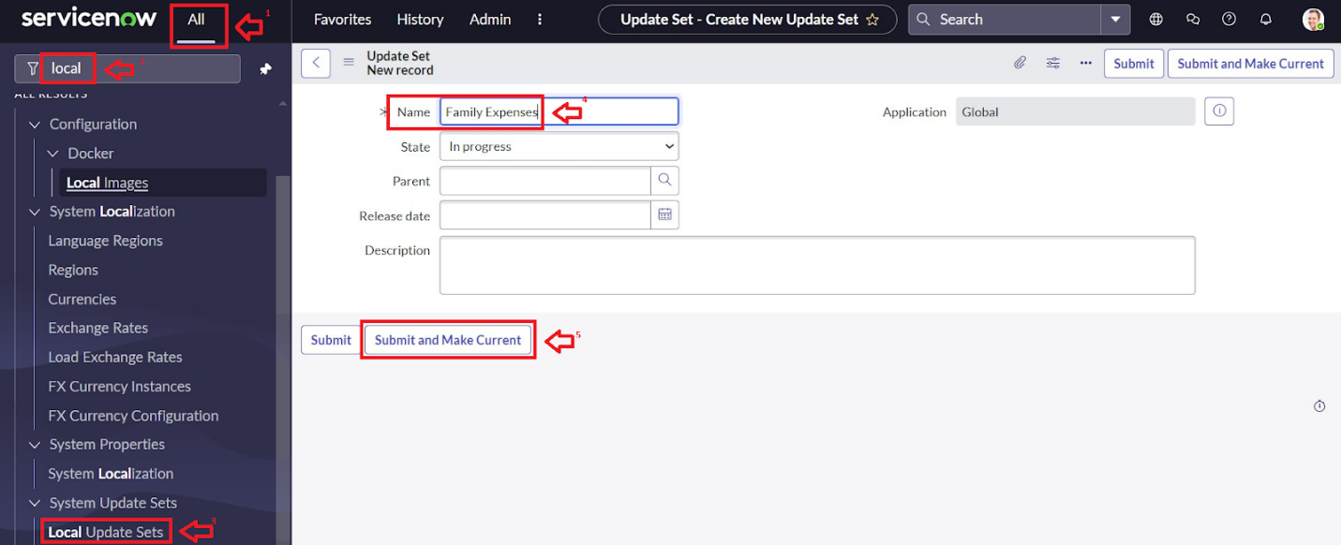Then click on Submit and Make current.

2.3. **Creation of New Update Set**

1. Go to All >> In the filter search for Local Update set > click on New.
2. Enter the Details as:

Name : Family Expenses

1. Then click on Submit and Make current.



2.4. **Creation of Table(Daily Expenses)**

2.4.1. **Creation of Daily Expenses Table**

1. Go to All > In the filter search for Tables > click on New.
2. Enter the Details:

Label : Daily Expenses

Name : Auto-Populated

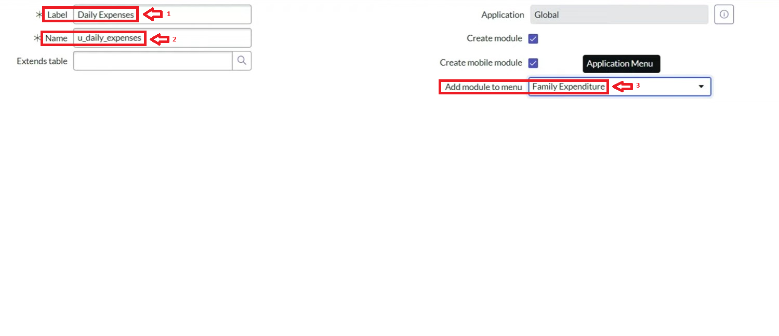Add Module to menu : Daily Expenditure

1. Go to the Header and right click there>> click on Save.

2.4.2. **Creation of Columns(Fields)**

1. Near Columns Double click near insert a new row.
2. Give the details as:

Column label : Number

Type : String

1. Double click on insert a new row again
2. Give the details as:

Column label : Date

Type : Date

1. Double click on insert a new row again
2. Give the details as:

Column label : Expense

Type : Integer

1. Double click on insert a new row again
2. Give the details as:

Column label : Family Member Name

Type : Reference

Max length : 800

1. Double click on insert a new row again
2. Give the details as:

Column label : Comments

Type : String

Max length : 800

11. Go to the Header and right click there>> click on Save.

2.4.3. **Making Number Field an Auto-Number**

* Double click on the Number Field/Column.
* Go down and double click on Advanced view
* In Default Value:

Use dynamic default : check the box

Dynamic default value : Get Next Padded Number

* 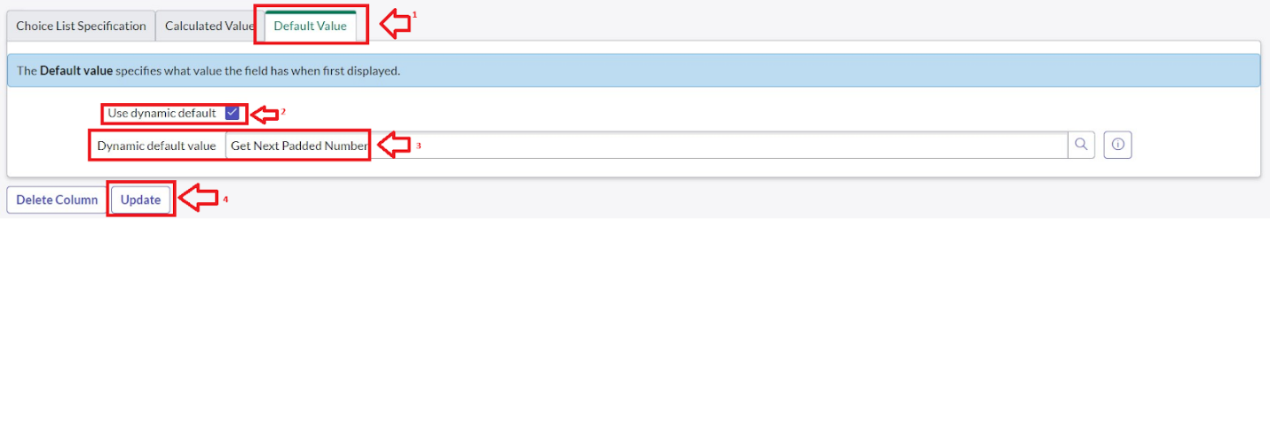Click on Update.
* Go to All >> In the filter search for Number Maintenance >> select Number Maintenance
* Click on New.
* Enter the below Details:

Table : Family Expenses

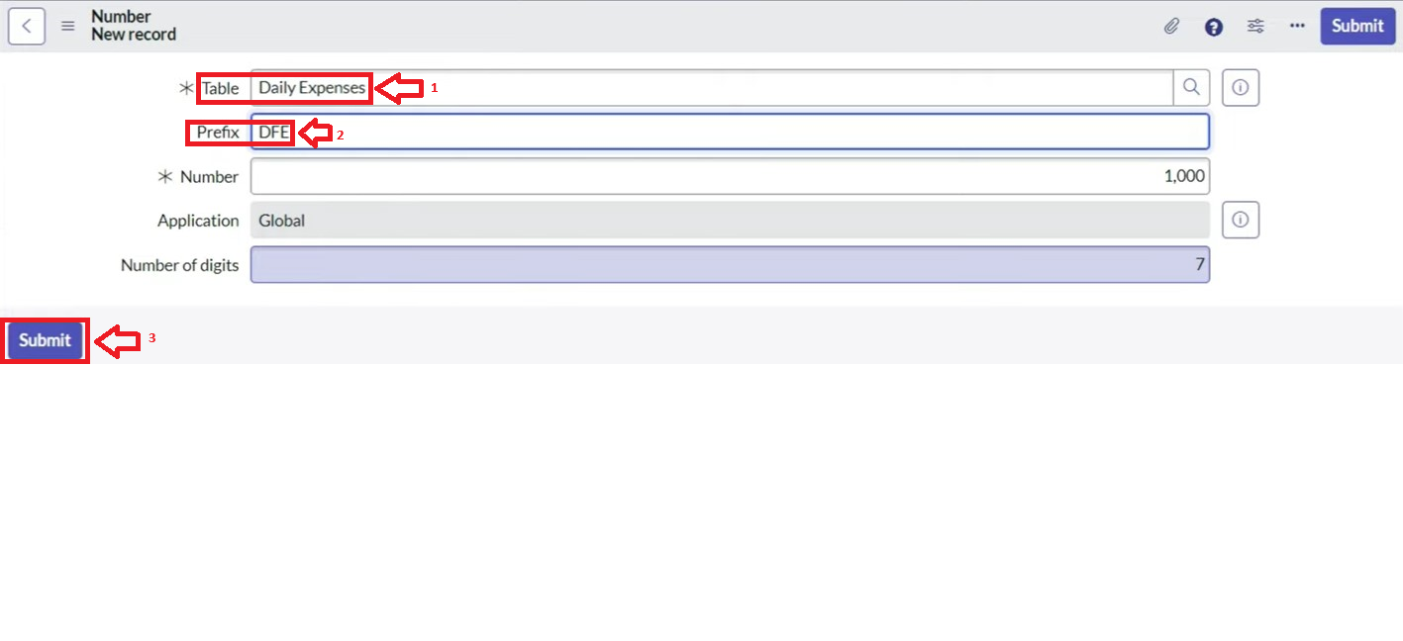Prefix : MFE

* Click on Submit.

2.4.4. **Configure the Form**

1. Go to All >> In the filter search for Daily Expenses >> Open Daily Expenses
2. Click on New
3. Go to the Header and right click there>> click on Configure >> Select Form Design
4. 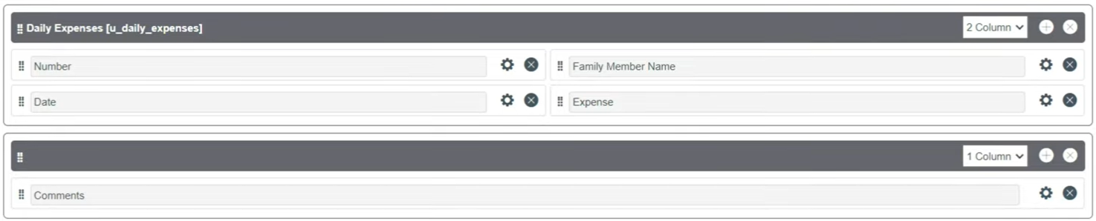Customize or Drag Drop the form as per your requirement.
5. Make Number Read-Only Field by clicking on the gear icon and checking Read-Only
6. Make Date, Family Member Name Mandatory Field by clicking on the gear icon and checking Mandatory
7. Click on Save.

2.5. **Creation of Family Expenses Table**

1. Go to All > In the filter search for Tables > click on New.
2. Enter the Details:

Label : Family Expenses

Name : Auto-Populated

New menu name : Family Expenditure

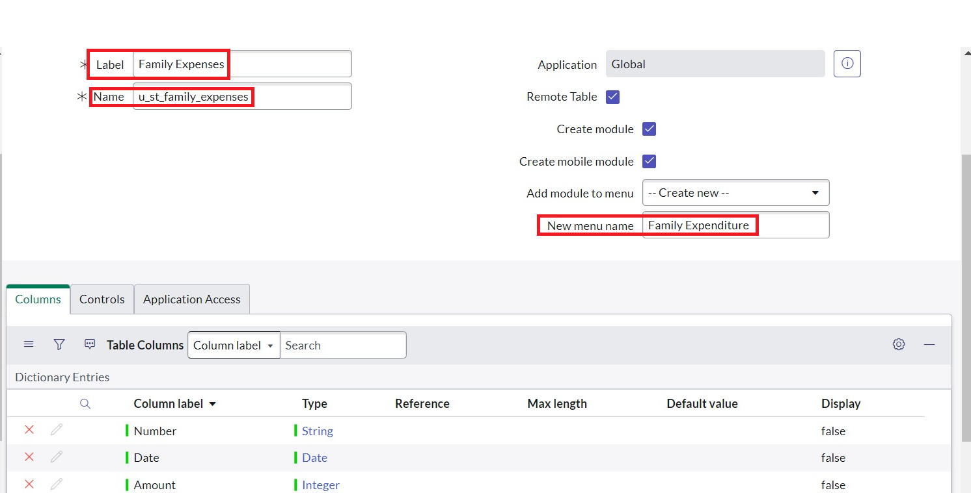

1. Go to the Header and right click there>> click on Save.

2.5.1. **Creation of Columns(Fields)**

1. Near Columns Double click near insert a new row.
2. Give the details as:

Column label : Number

Type : String

1. Double click on insert a new row again
2. Give the details as:

Column label : Date

Type : Date

1. Double click on insert a new row again
2. Give the details as:

Column label : Amount

Type : Integer

1. Double click on insert a new row again
2. Give the details as:

Column label : Expense Details

Type : String

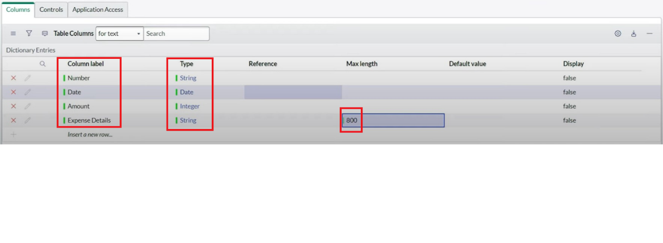Max length : 800

1. Go to the Header and right click there>> click on Save.

2.5.2. **Making Number Field an Auto-Number**

1. Double click on the Number Field/Column.
2. Go down and double click on Advanced view
3. In Default Value:

Use dynamic default : check the box

Dynamic default value : Get Next Padded Number

4. Click on Update.



Go to All >> In the filter search for Number Maintenance >> select Number Maintenance

Click on New.

Enter the below Details:

Table : Family Expenses

Prefix : MFE

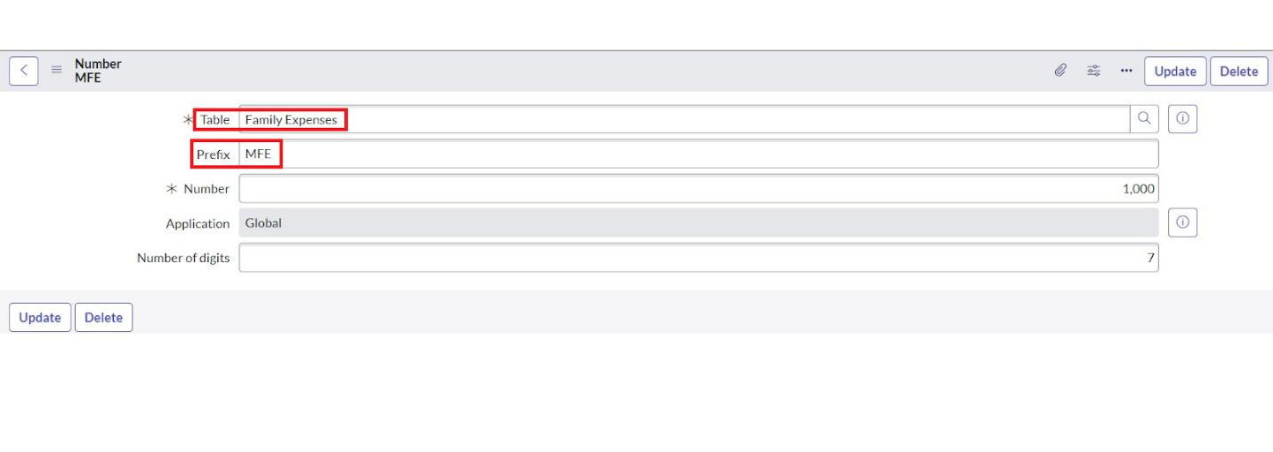

Click on Submit.

2.5.3. **Configure the Form**

1. Go to All >> In the filter search for Family Expenses >> Open Family Expenses
2. Click on New
3. Go to the Header and right click there>> click on Configure >> Select Form Design
4. 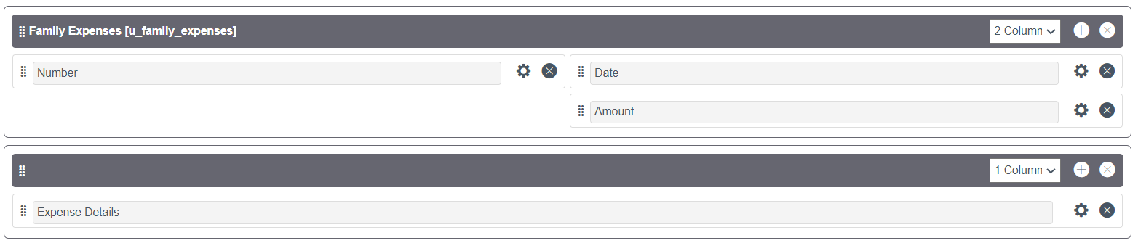Customize or Drag Drop the form as per your requirement.
5. Make Number Read-Only Field by clicking on the gear icon and checking Read-Only
6. Make Date, Amount Mandatory Field by clicking on the gear icon and checking Mandatory
7. Click on Save.

2.6. **Creation of Relationship between Family Expenses and Daily Expenses tables**

1. Go to All >> In the filter search for Relationships >> Open Relationships
2. Click on New.
3. Enter the details:

Name : Daily Expenses

Applies to table : Select Family Expenses

Daily Expenses : Select Daily Expenses

1. Click Save.

2.7. **Configuring Related List on Family Expenses**

1. Go to All >> In the filter search for Family Expenses >> Open Family Expenses
2. Click on New
3. Go to the Header and right click there>> click on Configure >> Select Related Lists
4. Add Daily Expenses to the Selected Area.
5. Click on Save

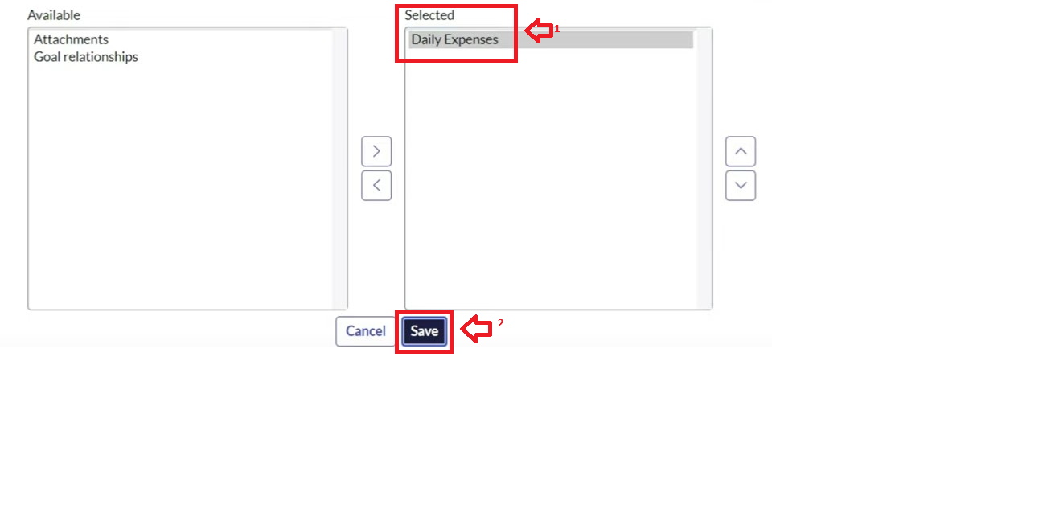

2.8. **Creation of Business Rules**

1. Go to All >> In the filter search for Business Rules.
2. Under System Definition Select Business Rules then click on New.
3. Enter the Details:

Name : Family Expenses BR

Table : Select Daily Expenses

Check Advanced

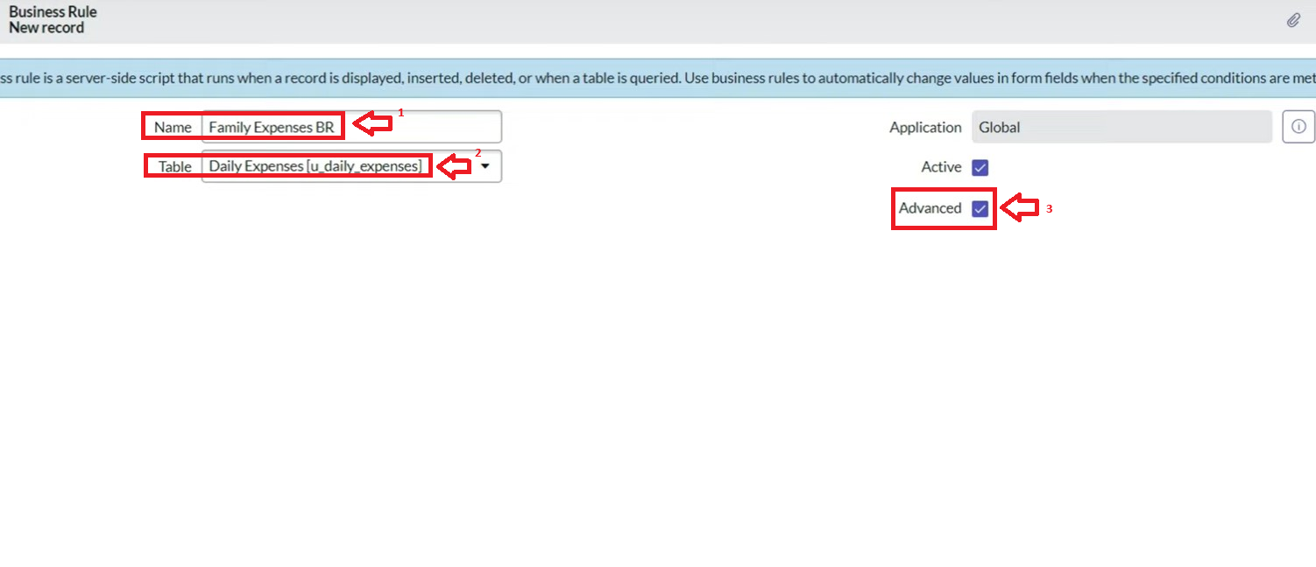

1. In when to run Check Insert and Update

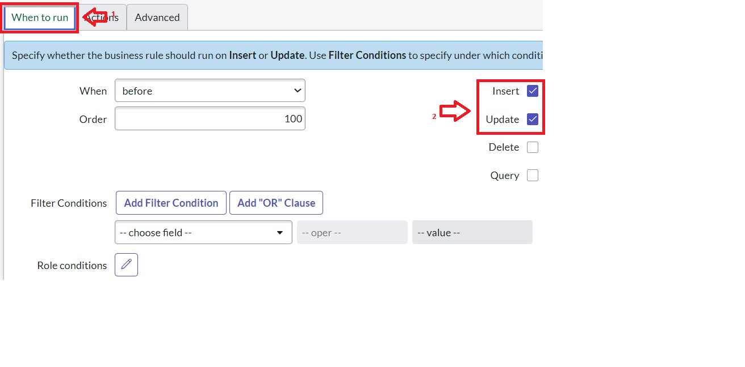

1. In Advance(we write the code): Write the below code >>

(function executeRule(current, previous /*null when async*/) {

var FamilyExpenses = new GlideRecord('u_family_expenses');

FamilyExpenses.addQuery('u_date',current.u_date);

FamilyExpenses.query();

if(FamilyExpenses.next())

{

FamilyExpenses.u_amount += current.u_expense;

FamilyExpenses.u_expense_details += ">"+current.u_comments+":"+"Rs."+current.u_expense+"/-";

FamilyExpenses.update();

}

else

{

var NewFamilyExpenses = new GlideRecord('u_family_expenses');

NewFamilyExpenses.u_date = current.u_date;

NewFamilyExpenses.u_amount = current.u_expense;

NewFamilyExpenses.u_expense_details += ">"+current.u_comments+":"+"Rs."+current.u_expense+"/-";

NewFamilyExpenses.insert();

}

})(current, previous);

1. Go to the Header and right click there>> click on Save.

2.9. **Configure the Relationship**

1. Go to All >> In the filter search for Relationships >> Open Relationships.
2. In that, open Daily Expenses Relationship.
3. For Applies to table : Select Family Expenses.
4. In Query with : write the below Query.

(function refineQuery(current, parent) {

// Add your code here, such as current.addQuery(field, value);

current.addQuery('u_date',parent.u_date);

current.query();

})(current, parent);

1. 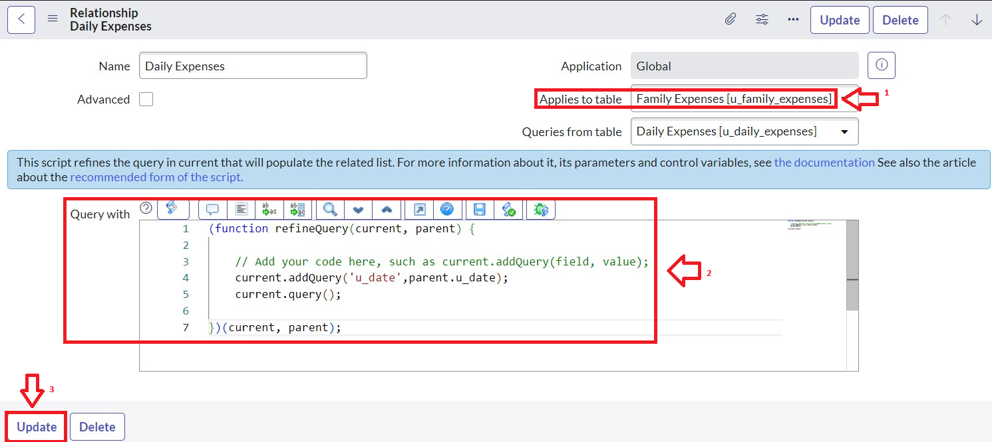Click on Update.

2.10. **Conclusion**

Thus the Family expension calculation system has been developed in the developer instance.

**Chapter : 3 – Using Family Expenses Calculation System as an user**